MSA-ISPT 2023

Sponsorship Prospectus
Perth
03 – 06 December 2023

Invitation
The International Congress on Separation and Purification Technology (ISPT) is the premier membrane science and technology event, supported by Separation and Purification Technology — an Elsevier flagship journal, and International Society for Separation and Purification Technology, for connecting membrane technology researchers, developers, manufacturers and users. This year, we are pleased to announce the conference will be co-hosted by The Membrane Society Australasia and The International Society for Separation and Purification Technology (MSA-ISPT 2023) and will be held from 3rd – 6th December 2023, at Perth, Australia. The conference is expecting a few hundreds of international delegates from around the world, in academic, research and commercial sectors with membrane technologies for a wide range of applications.
We cordially invite you to MSA-ISPT 2023 as a conference sponsor to showcase your organisation’s achievements and offerings and raise your profile to a national and international audience within the membrane fabrication and application sector. You can choose from a set of sponsorship packages available or request a program specifically tailored to suit the need of your organisation.

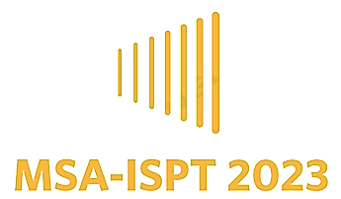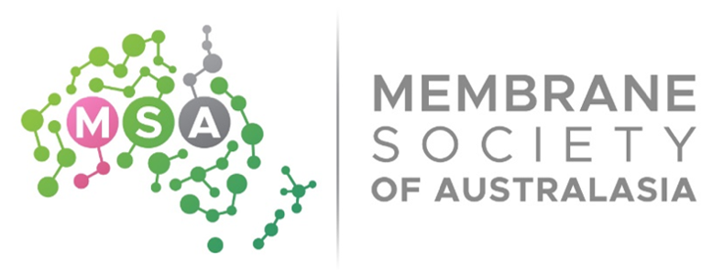

The Conference
The MSA-ISPT will feature a wide range of expert speakers, industry leaders, and academic researchers, who will share their insights, expertise, and perspectives on a range of topics related to membrane science and technology. With a focus on cutting-edge research and real-world applications, we are confident that this year's conference will be a valuable and rewarding experience for all attendees.
In addition to the exciting technical program, we also have a range of social events and networking opportunities lined up, giving you the chance to connect with fellow professionals in a relaxed and informal setting.
For further information, visit the MSA-ISPT 2023 website at: https://www.membrane-australasia.org/msa-ispt

Venue
MSA-ISPT is scheduled to be held at the Hyatt Regency Perth, a 5-star luxury venue located in the heart of East Perth with the view of the Swan River. It offers a visually inspiring and world-class environment to accommodate and enhance new styles of conference experience.
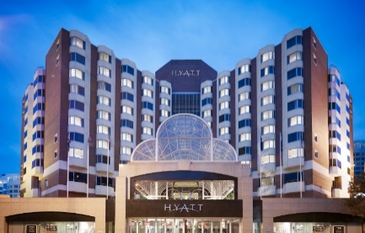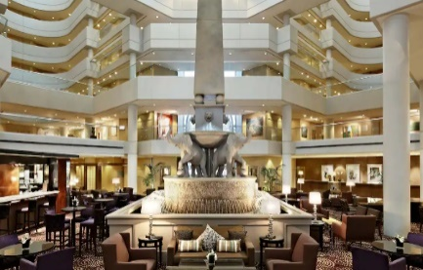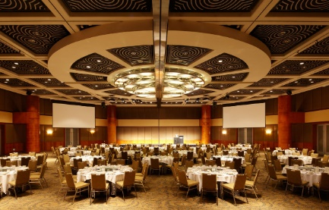

Key Themes and topics
1. New Membranes and Materials for Separations
- Inorganic membranes (ceramic membranes, metallic membranes)
- Polymeric membranes
- Ion-conducting polymer/hybrid membranes
- Mixed matrix membranes
- Stimuli and smart responsive membranes
- Carbon materials
- Zeolites/molecular sieves
- Metal-organic frameworks/covalent-organic frameworks/hydrogen-bonded organic frameworks
2. Emerging Separation Technologies for Clean Air, Water and Energy
- Pressure driven filtration (MF, UF, NF, RO)
- Activity driven separation (FO, dialysis)
- Electrochemical Separations (electrolysis, capacitive deionisation)
- Thermal separation (membrane distillation)
- Crystallization strategies (membrane crystallization)
- Biomass to bioproducts and biofuels
- Membrane bio-reactors (bio-reactors, contactors, catalytic reactors, liquid membrane reactors)
- Integrated or hybrid membrane processes
- Ionic liquids: novel separation and reaction process
- Fouling and cleaning strategies
- Scale-up and industrial applications of adsorption and membrane processes
3. Applications of Membranes
- Water treatment
- Gas separation
- Ion separation
- Energy storage and utilization (batteries, hydrogen generation, CO₂ conversion)
- Specific resource recovery (ultra-selective membranes and strategies)
- Biotechnology (bio-refinery and fuel production)
- Atmospheric capture of water and humidifiers
- Air separation (particle matter, viruses)
- Food security and food processing
- Microfluidics and membranes for small batch separation
- Industrial usages textiles, chemical and pharmaceutical industries
- Biological and healthcare applications of membranes (cell separation, virus removal, nutrient or resource recovery)
- Integration of advanced applications in future materials and devices (biosensors, electrochemical devices)
- Space applications of membranes (low gravity applications)
4. Carbon Capture Science and Technology
- Adsorbent-based gas separations and CO₂ capture
- Membrane-based CO₂ Capture
- Atmospheric capture of greenhouse gases
- Industry – case studies (experience and challenges)
5. Separation Modelling and Simulation
- Molecular simulations for membranes and adsorbents
- Molecular simulations of structure to performance relationships
- Modelling transport across membranes and adsorbents
- Modelling and simulation of separation systems
- Modelling and prediction of general membrane performance
6. Advanced Characterization Techniques for Separation Materials
- Non-destructive porous properties characterization techniques
- Mixed matrix membranes characterization
- Complex transport phenomena determination
- Application of novel surface properties evaluation
- Techniques for fouling and scaling evaluation
- Membrane autopsy of aged membranes

Key Dates
- Registration open: May 2023
- Notification abstract acceptance: August 2023
- Registration: Before 15 October 2023
- Conference: 3rd – 6th December 2023

msa-ISPT 2023 - A MUST ATTEND INDUSTRY EVENT
MSA-ISPT 2023 will be a significant international event for membrane technology researchers and industry. The conference offers a unique opportunity and platform to showcase the best and latest industry related products and services to this international group of current and future decision makers. With the travel restrictions easing, the conference is expecting approximately 300 delegates in attendance. In addition, MSA-ISPT reaches out to a broader group of professionals and young researchers in the Asian and Oceania region and is affiliated with the wider international research community with associations throughout Europe and North America. MSA-ISPT 2023 will provide you with a unique opportunity to increase your brand awareness and inform and influence this community with the latest product, technology and service trends.

Sponsorship Opportunities
The conference committee are dedicated to providing exhibition and sponsorship opportunities to support your branding and positioning requirements. A list of standard sponsorship packages is outlined below, however, sponsorship packages can be tailored to suit individual requirements. To secure sponsorship, please use the sponsorship booking form attached to this prospectus or contact Li Gao (+61 3 9552 3752, li.gao@sew.com.au).

Packages

Platinum Sponsorship Package, $12000
PLATINUM | - Exhibition space  - Two full pages advertisement in the conference proceedings  - One opportunity to insert promotional material into the delegate satchel  - A delegate list  - 5 complimentary attendee registrations (incl conference gala dinner)  - Opportunity for 10 minutes speech at the opening ceremony  - Opportunity for 10 minutes speech at dinner  - Acknowledgement as platinum sponsor through corporate logo on conference signage  - Acknowledgement as platinum sponsor through corporate logo on proceedings  - Company logo and 200-word company synopsis in conference proceedings AND on conference website with hyperlink to your company website.  - Brochures distributed at conference

Gold Sponsorship Package, $9000
GOLD | - Exhibition space  - One full page advertisement in the conference proceedings  - One opportunity to insert promotional material into the delegate satchel  - A delegate list  - 3 complimentary attendee registrations (incl conference gala dinner)  - Opportunity for 5 minutes speech at the opening ceremony  - Opportunity for 5 minutes speech at dinner  - Acknowledgement as gold sponsor through corporate logo on conference signage  - Acknowledgement as gold sponsor through corporate logo on proceedings  - Company logo and 100-word company synopsis in conference proceedings AND on conference website with hyperlink to your company website.  - Brochures distributed at conference

Silver Sponsorship Package, $6000
SILVER | - Exhibition space  - One half page advertisement in the conference proceedings  - One opportunity to insert promotional material into the delegate satchel  - A delegate list  - 2 complimentary attendee registrations (incl conference gala dinner)  - Acknowledgement as silver sponsor through corporate logo on conference signage  - Acknowledgement as silver sponsor through corporate logo on proceedings  - Company logo and 50-word company synopsis in conference proceedings AND on conference website with hyperlink to your company website.  - Brochures distributed at conference

Bronze Sponsorship Package, $3000
BRONZE | - Exhibition space  - One quarter page advertisement in the conference proceedings  - One opportunity to insert promotional material into the delegate satchel  - A delegate list  - 1 complimentary attendee registration (incl conference gala dinner)  - Acknowledgement as bronze sponsor through corporate logo on conference signage  - Acknowledgement as bronze sponsor through corporate logo on proceedings  - Company logo and 50-word company synopsis in conference proceedings AND on conference website with hyperlink to your company website  - Brochures distributed at conference

ADDITIONAL Sponsorship Opportunities

Single Event Sponsorship Opportunities
BRANDING AND VISIBILITY | Welcome Reception  $2500 (eXCLUSIVE)  - Banner displayed prominently at event  - 1 complimentary attendee registration  - Company logo displayed in conference proceedings AND on conference website with hyperlink to your company website  Exhibitor  $2500  - Exhibition space  - Company logo displayed in conference proceedings AND on conference website with hyperlink to your company website  - 1 complimentary attendee registration  Conference Proceedings Advertisement  $1000 (TEN spaces available)  - One full page advertisement in the official conference proceedings (design to be supplied by sponsor)  - Company logo displayed on conference website with hyperlink to your company website  Poster session  $1500 (eXCLUSIVE)  - Banner displayed prominently at event  - Company logo displayed in conference proceedings AND on conference website with hyperlink to your company website |  | NETWORKING OPPORTUNITY | session THEMES & TOPICS  $1000 per topic (7 TOPICS AVAILABLE)  - Exclusive company logo and advertisement displayed in one introductory slide of the session and the break before the session  - One A4 size advertisement on the IMSTEC2022 website  - Company logo displayed in conference proceedings AND on conference website with hyperlink to your company website  BARISTA CART  $2000 (EXCLUSIVE)  - Banner displayed beside barista cart  - Company logo displayed in conference proceedings AND on conference website with hyperlink to your company website  - 1 complimentary attendee registration  Gala Dinner  $3000 (EXCLUSIVE)  - A tabletop exhibition display  - Opportunity to give a short address at the beginning of the dinner  - Company logo displayed in conference proceedings AND on conference website with hyperlink to your company website  - 1 complimentary attendee registrations  Name badge and lanyard  $1500 (eXCLUSIVE)  - Company logo displayed on delegate name badge and lanyard  - Company logo displayed in conference proceedings AND on conference website with hyperlink to your company website

Sponsorship Booking Form
To book your sponsorship package please read, complete and sign the booking form AND the terms & conditions form (see next page), and return by email to the contact listed below. Alternatively, to discuss tailoring a package to your specific needs please contact Li Gao (+61 3 9552 3752, li.gao@sew.com.au).

Contact details
Company contact name for correspondence
Title (Prof. Dr. Mr. Mrs)
Name
Job Title
Organisation
Address
State/Country
Post/ Zip Code
Telephone
Email

2. Sponsorship type

(gst Exclusive)
 | Gold Sponsor | $9,000
 | Silver Sponsor | $6,000
 | Bronze Sponsor | $3,000
ADDITIONAL SPONSORSHIP OPPORTUNITY
Branding and Visibility
 | Welcome Reception | $2,500
 | Exhibition Display | $2,500
 | Conference Proceedings Advertisement | $1,000
Networking Opportunity
 | Early Career Research Event / Workshop | $1,500
 | Barista Cart | $2,000
 | Gala Dinner | $3,000

3. HOW TO PAY
Total Amount Payable | $AUD

I agree to be invoiced for the items selected
I will arrange a bank transfer to Membrane Society of Australasia. Please send me the payment details

4. SIGN AND DATE THE FORM
I have read and agree to abide by the SPONSORSHIP & EXHIBITION TERMS AND CONDITIONS as outlined below, and I understand that this form confirms my booking. I accept that from now on charges will be imposed for cancelled bookings, and that up to the full fee will be payable

Signature
Date

5. RETURN TO
Return booking form to:
MSA Contact: Dr. Andrea Merenda
Address: RMIT University, School of Science, Applied Chemistry and Environmental Science
124 La Trobe Street, Melbourne VIC 3000
Phone: +61 0406113635
Email: andrea.merenda@rmit.edu.au

Sponsorship & Exhibition Terms and Conditions
The following terms and conditions apply to your application to sponsor and/or exhibit:
- DEFINITIONS
Event means the event referred to in the Booking Application
Us/We refers to the conference organising committee
You refers to the entity submitting the booking application form to sponsor and/or exhibit
- APPLICATION
You will submit the Booking Application Form to sponsor and/or exhibit
- APPROVAL
The sponsorship/exhibition will be confirmed upon return to You of the approved booking application form, together with a tax invoice for payment of a 50% deposit. Payment of the 50% deposit is required to confirm your sponsorship/exhibition and is required 14 days after receipt of the invoice. Your company logo and profile will only feature on the conference website and any documentation once this deposit has been paid.
- PAYMENT
Payment of the 50% deposit is required upon confirmation of your sponsorship/exhibition. The deposit is non-refundable and will be deducted from the booking fee. Of the balance owing, the final 50% will be due 30 days prior to the conference. Failure to pay your sponsorship/exhibition invoice may result in your sponsorship item or exhibition stand being released for sale. All booking applications received within 30 days of the commencement of the Event must include full payment. International payments must include provision for bank fees and exchange rates in the payment amount.
- CANCELLATION
If You cancel your sponsorship/exhibition, your deposit will not be refunded. If You cancel your sponsorship/exhibition within 60 days of the Event, you will not receive any refund.
- CHANGES
We reserve the right to amend existing unsold sponsorship packages or add additional sponsorship packages as required without notice to confirmed sponsors and exhibitors. We reserve the right to rearrange the floor plan and/or relocate any sponsorship or exhibition display without notice to You.

The organising committee reserves the right to change the venue, dates or duration of the Event if circumstances demand. In the event of a change of venue, date or duration, the agreement to participate will remain in force as long as the sponsor/exhibitor is informed at least one month before the planned Event.
- STANDS / EXHIBITOR SPACE
Exhibition space and placement will be offered to sponsors first and then sold in accordance with the date of exhibitor application receipt. We must be advised of details of custom-built exhibit stands a minimum if six weeks prior to commencement of the Event. All display structures require our approval.
- INSURANCE
Public liability insurance to a minimum of AUD $10million must be taken out by You. A copy of the insurance certificate must be provided to Us at least four weeks prior to the Event.
- EXCLUSIONS
All information supplied to You in relation to the Event is accurate to the best of our knowledge and does not constitute a warranty. Any inaccuracy or mistake will not entitle You to cancel your booking without penalty. All estimates of attendee/delegate numbers attending the Event are estimates only, and You agree that We are not responsible for any discrepancy in these estimated numbers.
- FORCE MAJEURE
In no event shall We be responsible or liable for any failure or delay in the performance of our obligations arising out of or caused by, directly or indirectly, forces beyond our control.
- WAIVER OF LIABILITY
You expressly waiver all rights, if any, to assert any claims against Us, and release Us from all liability for any loss (including consequential losses), damage or claims arising out of injury to members of the public or damage to any persons’ property, materials or possessions by reason of the works, acts or omissions of You, your employees, servants or agents.

